Lab Evaluation-1
5/2/2026
CB.EN.U4CCE23042
S M Veankata Krishnan
GitHub URL : https://github.com/veankatakrishnan/festivals-autism-kids-game
Deployed URL : https://veankatakrishnan.github.io/festivals-autism-kids-game/
About the Use Case:
This application is an educational game designed for children, particularly focusing on those with autism. It aims to teach about various cultural festivals (Diwali, Christmas, etc.) through interactive and engaging mechanics.
Key Features:
- Visual Learning: Using "Shadow Matching" games to help recognize objects by shape.
- Decoration Activity: A "Decorate" mode to encourage creativity and fine motor skills (dragging and dropping).
- Knowledge Checks: A simplified "Quiz" to reinforce learning with hints and positive reinforcement.
- Parent Feedback: A dedicated section for parents to provide feedback on the app's effectiveness.

Concept & Code Proof /Screenshot:
Concept | Code Proof/Screenshot
Function component | 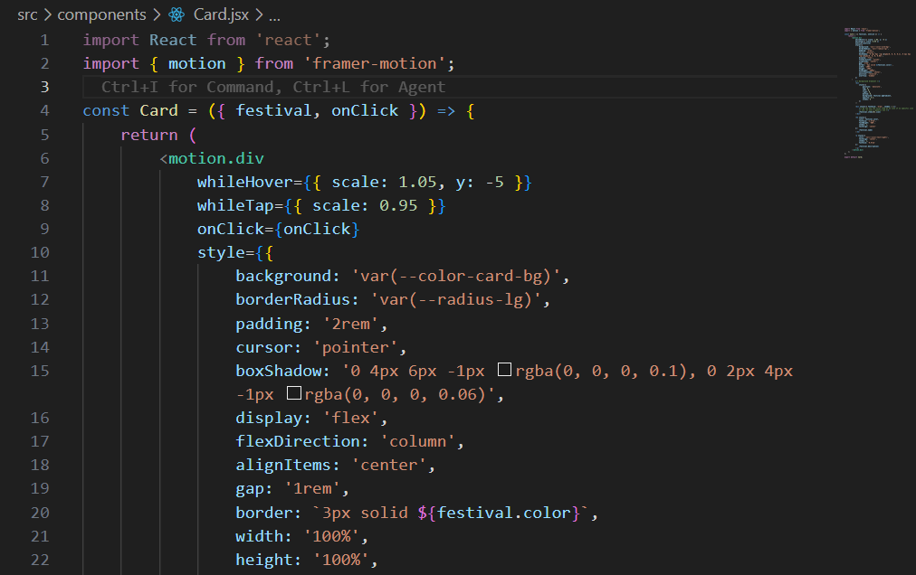  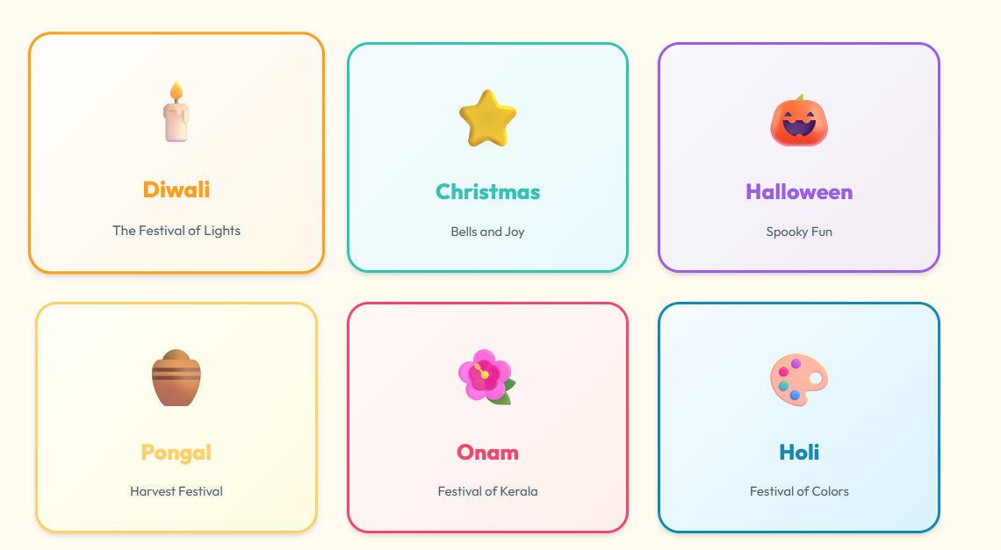
Class Component | 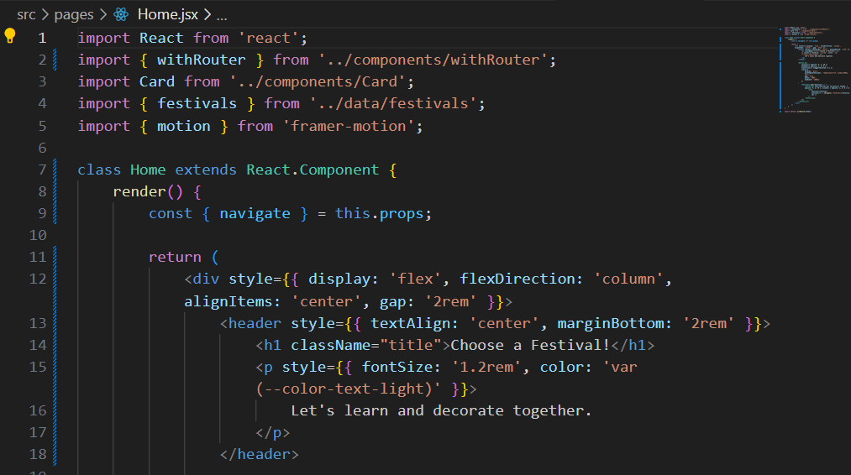  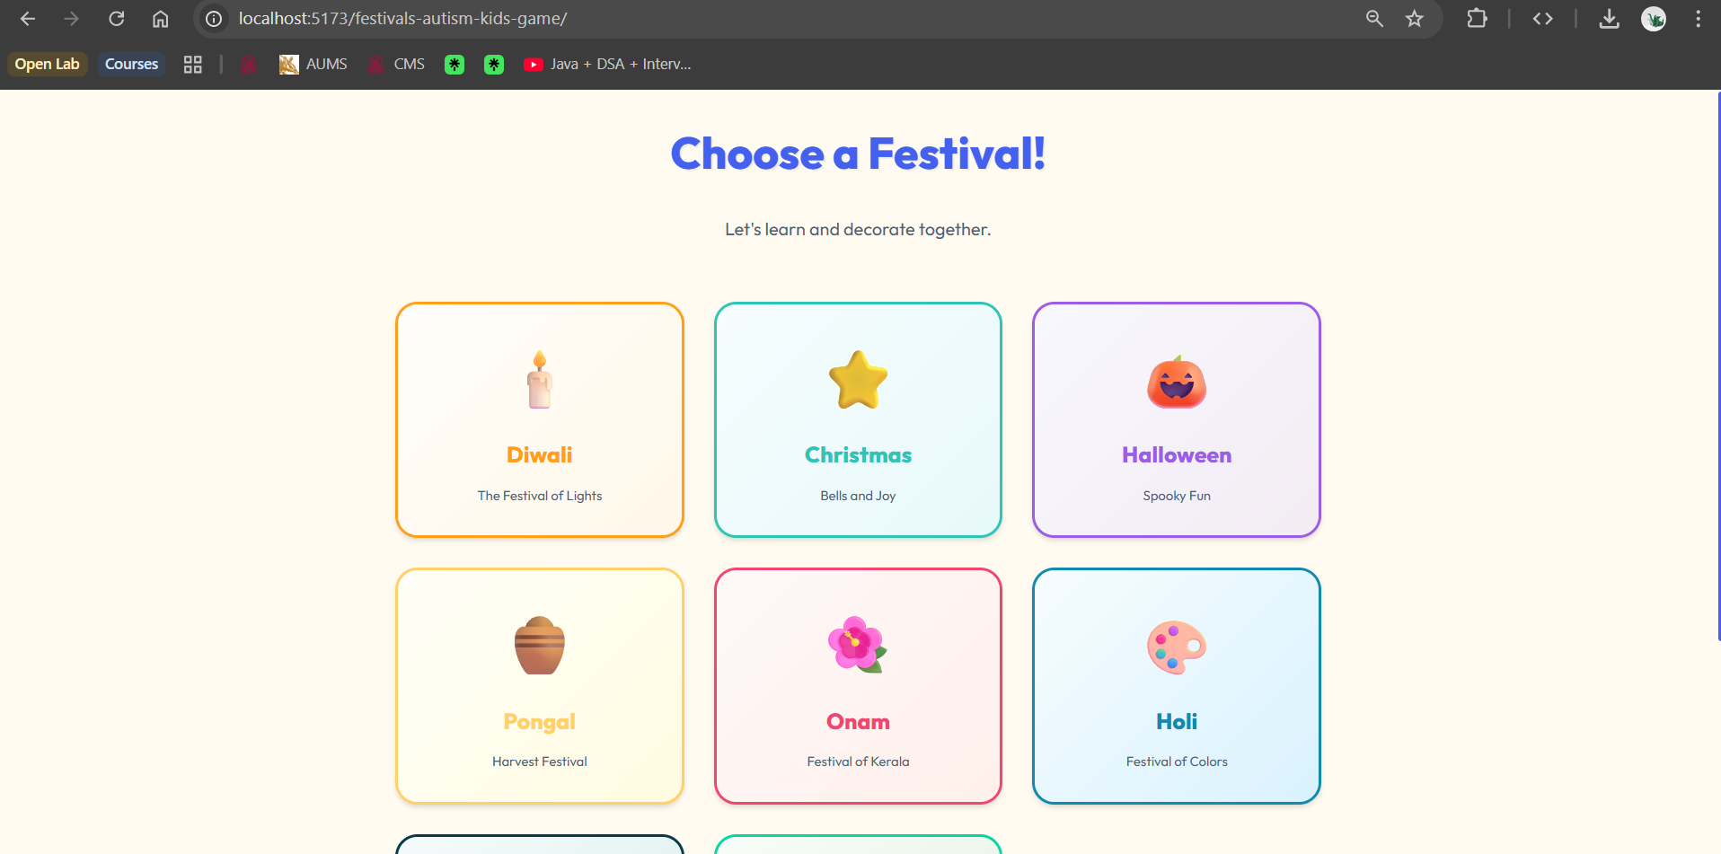
useState Hook | 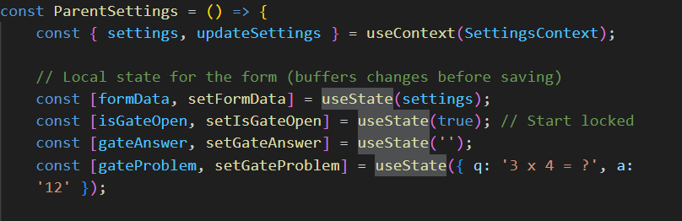  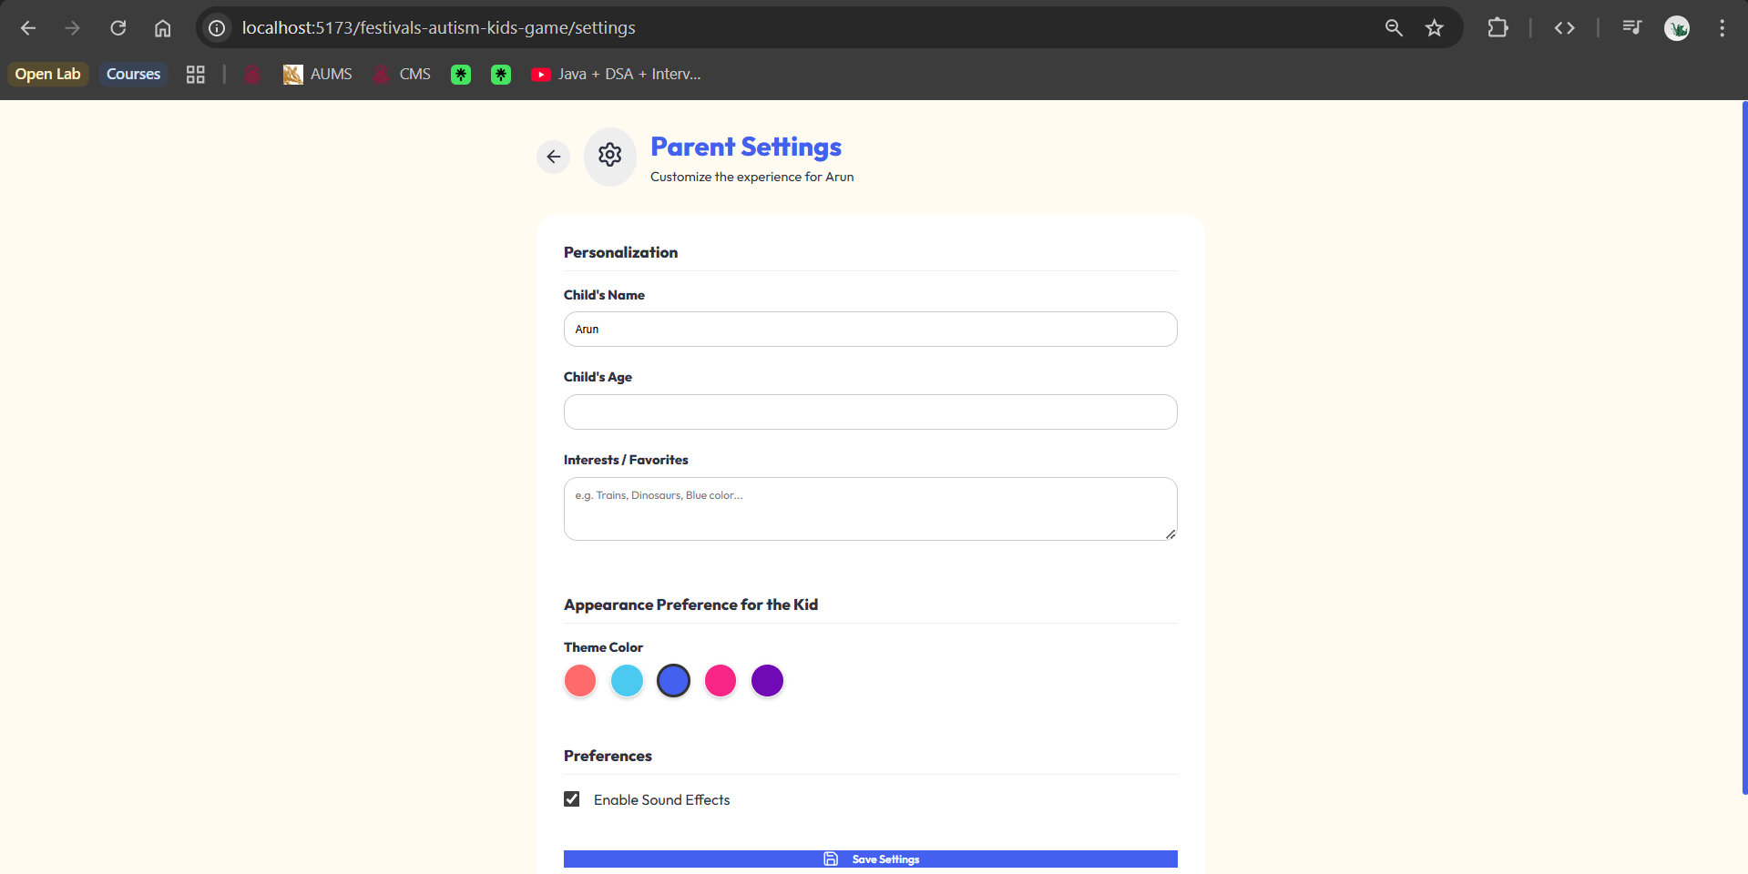
useEffect Hook | 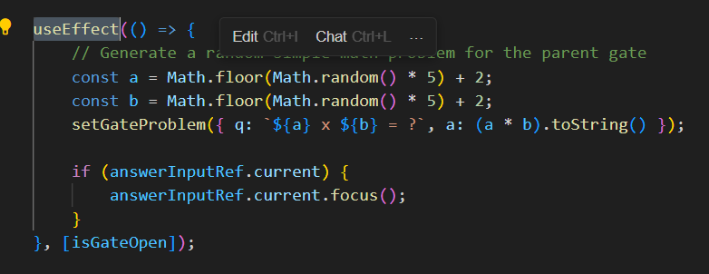  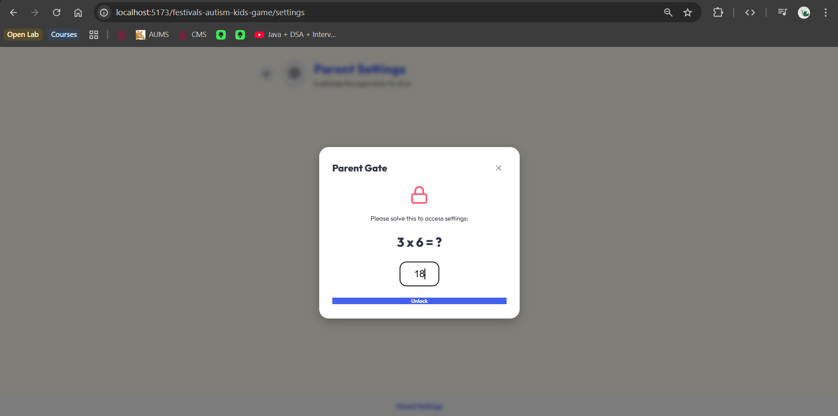
Forms | 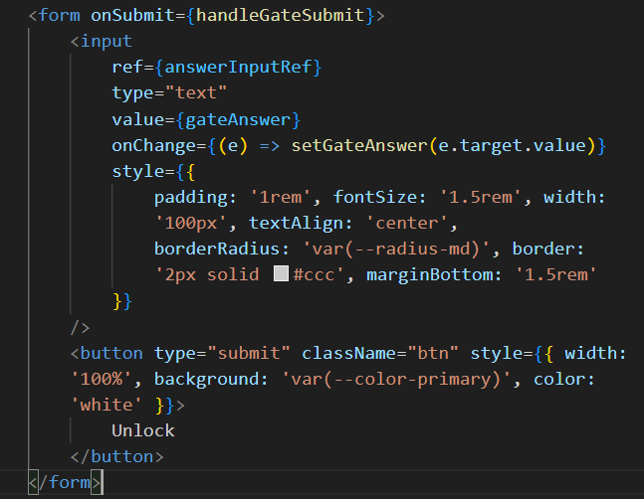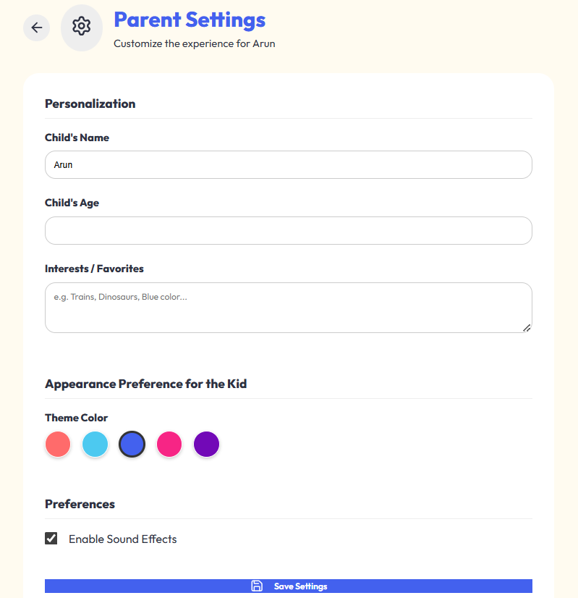
createContext() | 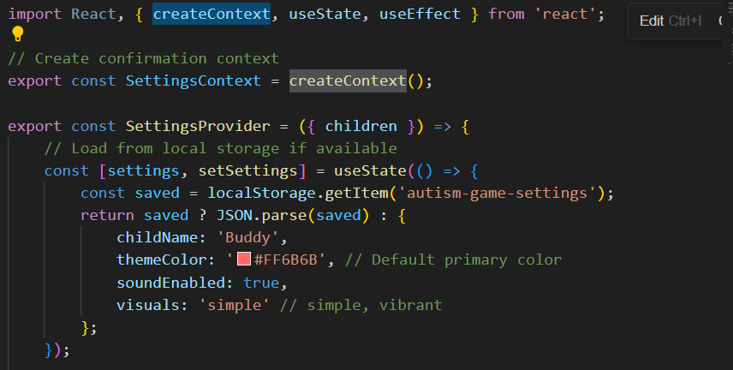  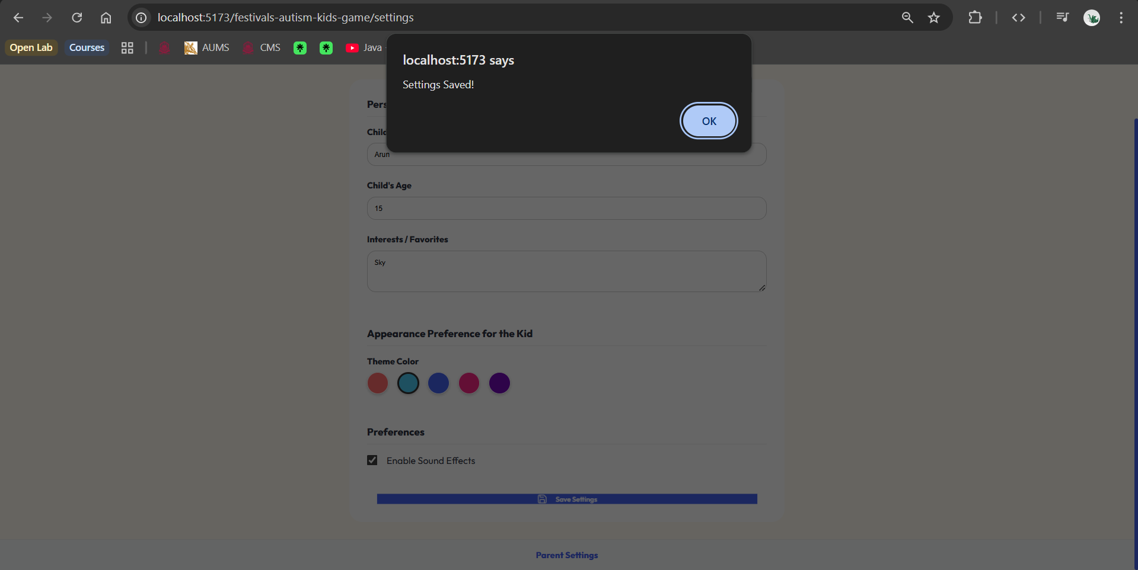
useRef() | 